For Immediate Release
Press Contact: Michelle Chapman
617.532.1210 | mchapman@bochcenter.org

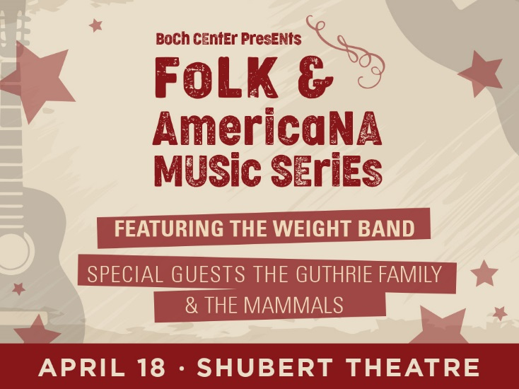

BOCH CENTER ANNOUNCES NEW
FOLK & AMERICANA MUSIC SERIES

APRIL 18 INAUGURAL PERFORMANCE WILL FEATURE THE WEIGHT BAND, THE GUTHRIE FAMILY & THE MAMMALS

Boston, MA (March 12, 2018) – The Boch Center, one of the nation’s leading nonprofit performing arts institutions, today announced the launch of a new Folk & Americana Music Series to celebrate the genre’s rich musical history and influence. The series seeks to spotlight iconic and emerging artists and introduce new audiences to the genre. The Folk & Americana Music Series will include regular concerts with Woodstock-based artists The Weight Band and rotating special guests—giving each concert its own unique experience. It will also include solo performances with notable touring artists. The series will begin with an inaugural performance at the Boch Center Shubert Theatre on Wednesday, April 18, 2018 at 7:30PM, featuring The Weight Band and acclaimed folk artists The Guthrie Family and The Mammals. Tickets for the April 18 performance go on sale to the general public on Thursday, March 15 at 10:00AM.

The inaugural concert will be followed by four additional performances anchored by The Weight Band in the fall of 2018. Artist and show schedule will be announced at a later date. This music series is being launched in partnership with the David Bieber Archives. Notable archive items documenting the history of folk and Americana music will be on display at the Shubert Theatre during the April 18 performance.

“Boston has long been one of folk music’s most supportive and creative communities, and we are so excited to celebrate its rich history through our Folk & Americana Music Series and partnership with the David Bieber Archives,” said Josiah A. Spaulding, President & CEO of the Boch Center. “For decades, folk artists, including The Weight Band, have used music to tell a story and take a stand on important social issues. We’re proud to pay homage to this important genre and educate younger generations on its origin and legacy through this new music series.”

“With the launch of this vibrant concert series, I’m looking forward to showcasing many Americana and roots music artifacts from the past 80 years,” said David Bieber. “These original memorabilia items will definitely enhance and educate the theatre-going experience. The great spectrum of talent, from Woody Guthrie, Wilco and Billy Bragg to Bob Dylan and the Band, and all phases, from deep south to dust bowl and coffee house to house party, will be represented.”

The Weight Band originated in 2013 inside the famed Woodstock, New York barn of Levon Helm and includes former members and collaborators from The Band, the Levon Helm Band, the Rick Danko Group and the Midnight Ramble Band. Recently, The Weight Band revived the Americana musical tradition known as the Woodstock Sound on World Gone Mad, their first full-length album which also features Jackie Greene and co-writing contributions from Levon Helm.

World Gone Mad is now available on digital and physical platforms - including Spotify and iTunes. For more on The Weight Band, including their music video for “World Gone Mad” as well as a short documentary on their rich history, visit their website at www.theweightband.com.

“The Weight Band is thrilled to be participating in the Boch Center’s first-ever Folk & Americana Music Series, and we look forward to bringing our Woodstock-bred, Americana-infused style of performance to Boston in the months ahead,” said Jim Weider, who provides guitar, mandolin and vocals for The Weight Band. “Boston is in a class alone thanks to its deep connections to folk music history, so it is our unique privilege to be contributing to that legacy as part of this upcoming series.”

An iconic American singer-songwriter, Woody Guthrie was one of the most significant and influential figures in folk music. On April 18, members of his family, including Abe, Cathy, Annie and Sarah Lee, will join The Weight Band to honor Woody Guthrie’s rich and powerful legacy by performing one of his timeless classics. His songs, as Bob Dylan wrote, have “the infinite sweep of humanity in them.”

“We are incredibly honored and humbled to be part of this event and to represent our family and musical heritage,” added The Guthrie Family.

The Mammals, an Americana quintet from Woodstock, NY, will contribute their heartfelt songs and topical string-band fervor to the evening. In April, they will release a long-awaited new album, Sunshiner, which features the titular sustainability ode and other soulful & danceable numbers. Through their music, The Mammals connect timid generations, heal sore hearts and enchant tired minds.

Tickets for the April 18 performance go on sale to the general public on Thursday, March 15 at 10:00AM and are available at the Boch Center Box Office, bochcenter.org, or by calling (866) 348-9738.

WHAT: Folk & Americana Music Series

WHEN: Wednesday, April 18, 2018 at 7:30PM

WHERE: Boch Center Shubert Theatre

TICKETS ON SALE: Thursday, March 15, 2018 at 10:00AM

TICKETS: Tickets start at $25.00 / VIP packages available
(Price includes a $4.00 Facility Fee)

Tickets are available at the Boch Center Box Office, bochcenter.org, or by calling (866) 348-9738.

###

About the Boch Center – The Boch Center is one of the nation’s leading nonprofit performing arts institutions and a guardian of the historic Wang and Shubert Theatres. As New England’s largest cultural venue, the Boch Center is home to theater, classical and popular music, dance, comedy, opera, Broadway musicals, family entertainment, and more.
Located in Boston’s historic Theater District, the Boch Center also offers a diverse mix of educational and community outreach initiatives, including the City Spotlights Leadership Program and ArtWeek; collaborates with artists and local nonprofit arts organizations; preserves historic venues; and acts as a champion for Greater Boston’s arts and cultural community. Learn more at bochcenter.org.

